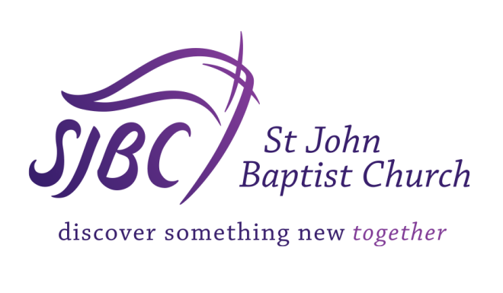

2023 Program and Event Evaluation Form

Please complete no later than 1 week after the event has occurred and return to Lisa Copelin (sjbc_ministryadmin@stjohnbaptistchurch.org)

Ministry Name:_________________________

Event Name: _____________________________

Event Location: ____________________________________

Event Date: _________

Start Time: ___________ End Time: ___________
Event Coordinator or Ministry Leader: ____________________

- Provide the below quantitative information about the event?
Attendance: _______

- Did you meet your goal? Yes ____ No ____

If No, please explain:

- Who was your target population?___________________ ( e.g. Youth, young adults, seniors)
Did you reach your target population? Yes___ No___
If No, please explain:

- Did you meet your financial goal? Yes ___ No ___

If No, please explain:

- Did you capture names and contact information of participants to use for future events?
Yes ___ No ___

- How did this event benefit SJBC in promoting its vision and mission?

- How did your ministry benefit from this event?

- Was your marketing plan successful? Yes ___ No ___

If No, please explain:

- Do you plan to hold this event next year? Yes___ No___

If yes, do you see potential for collaborating with another ministry or strategic partner?

- Please give a breakdown of the budget. Please submit all receipts and voucher to the Ministry Coordinator, Lisa Copelin (sjbc_ministryadmin@stjohnbaptistchurch.org) for approval. If needed, you may put this information on another sheet and attach to this report.

  - Expenses: Amount:

Total Expenses:

  - Income: (total collected)

Total Income:

  - Donations (if applicable)

Total Donations:

